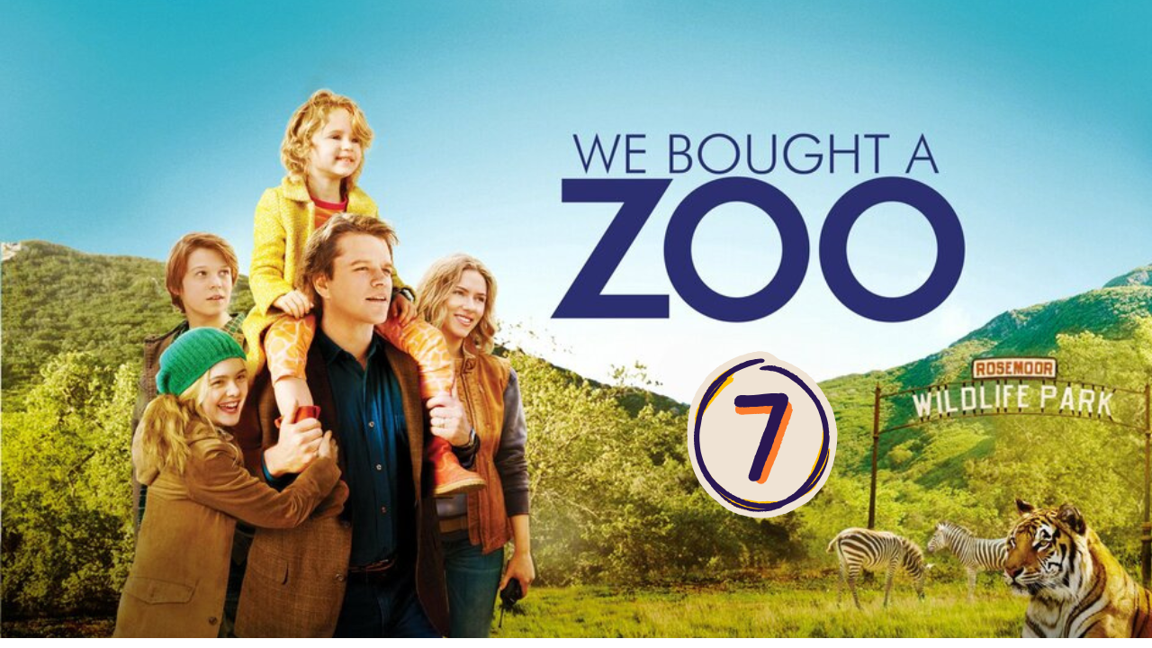
“We Bought a ZOO” (Scene 07)

Part 01 / Work on the Scene

- Scene events summary:

The scene begins with Mr. Mee in his office, where the secretary brings him the bills from the feed company that need to be paid. After a long and tiring day, Mr. Mee is obliged by his kids to drive to the grocery store to buy some butter. When he arrives home, he meets Kelly and tells her to go home, saying that he will finish her work instead.

Another problem occurs when Dylan goes to the garage to turn off the light. Curious about the snake box, he opens it. Surprised by the snakes, he runs away, leaving the box open behind him, and the snakes escape.

- Scene Discussion & Analysis:

- Q01: Did Benjamin seem to handle the ZOO expenses? What are the reasons (in your opinion)?
No, he didn’t. The reason behind this is that he isn’t working, so he doesn’t have enough money to handle the zoo’s expenses.
- Q02: How far is the nearest grocery store? And what would that indicate?
The grocery store is about nine miles from the zoo.
- Q03: Do you think Benjamin is about to give up on the ZOO dream? (your bet!!!)
No, I don’t think so.
- Q04: Did his son Dylan warm up to the ZOO place yet?
It seems that Dylan is starting to enjoy living in the zoo.
- Q05: If not, why? And how would you analyze that?
He starts to get along well with his father, and he is building new relationships with new friends.
- Q06: What did his father ask him to do in the garage?
Dylan’s father asked him to turn the light off in the garage.
- Q07: What did he find there? and what did he do with what he found?
He found the snakes’ carte and he open it.
- Q08: Do you think Dylan’s mistake in the garage will have dangerous consequences?
That Dylan’s mistake may cause disastrous consequences.

Part 02 / Acquired vocabulary & Grammar from the scene

- Acquired Vocabulary (OPTIONAL):

- To take over:
- Example in a sentence:
“ From now on I will take over the work, to make that it is done properly.”
- Overdue:
- Example in a sentence:
“The electrical company stopped the electricity meter because the bill was overdue.”

- Irregular Verbs:

Infinitive | Past simple | Past participle
To drive | drove | driven
To eat | ate | eaten
To forget | forgot | forgotten

Part 03 / TRANSCRIPTION: improve your listening (Optional)

Task: Transcribe sentences from the scene.
- Transcribe Sentence 01
- Hi guys I forgat to bay butter. How important is butter to this meal tonight, we … .And remember its nine miles each way to the grocery store, nine miles, nine miles there, nine miles back, so I think the question we need to ask our ourselves as a family is butter with your dad driving eighteen miles right now to there.

- Transcribe Sentence 02
Make sure that …, turn off the light in the garage. All the garage there is new shipment of exotic snakes, so you just leave them in the travel crates. I will put them in an exhibit in the morning.

Open discussion
\
- Topic of discussion: Benjamin Mee had to drive for 18 miles only to provide butter for his two kids. Don’t you think he is trying too hard to gain his kid’s approval? Should a father show his kids that he’d do anything in order to satisfy them? What makes a good father in your opinion? And what role does the father play in the good upbringing of his children?
(Students are free to participate and interact to share their own opinions.)
(Students are encouraged to prepare their arguments before the session.)
It is difficult to judge Mr. Mee given his circumstances, especially considering that he nearly lost his wife. He makes every effort to shield his children from the pain of her absence. Nevertheless, parents must be careful not to grant every request their children make, in order to prevent them from becoming spoiled or losing control. In my view, a good father teaches his children how to live harmoniously as a family, fostering helpfulness, forgiveness, love, and care. He also helps them understand that it is not always possible to give them everything they want, as these boundaries are ultimately for their own well-being.

